One Day Shipping

Project Progress Update

Matt Farrell - B00625174

Orjan Monsen - B00697153

Robert Tracey - B00699803

Johna Latouf - B00698246

November 7th, 2016

# Progress

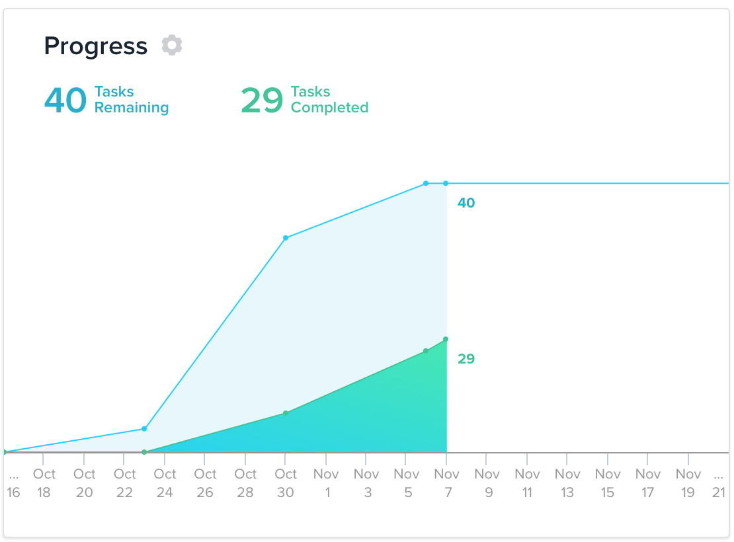

Figure 1: Sprint velocity chart for the first weeks of development.

We have currently completed over 50% of our initially-defined tasks, focusing on the establishment of game systems, environment, and AI.

## Environment & Art Style

We’ve created a single terrain city for our game environment. The terrain has been modeled and textured, and environment game objects have begun to be added into the scene.

The game environment consists of a city area, suburb area, and a third mountainous area for the headquarters of our evil organization. The city and suburbs have been populated with buildings. We are now refining building placement and adding props (sidewalks, fences, trees, etc.) to the environment. Currently, the environment is about 75% completed.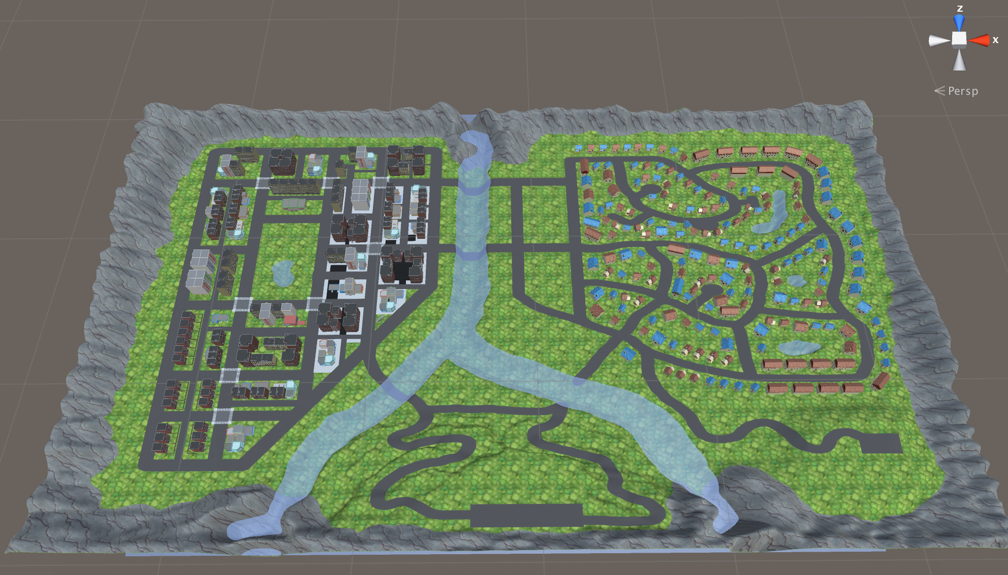

A low-poly style was chosen for the game, and assets were sourced or purchased from the Unity Asset store.

Figure 2: Top-down view of the game environment.

## Models, Animations & AIScreen Shot 2016-11-06 at 11.33.42 AM.png

Two character models are currently finished: the main character and the enemy postal workers (see figure 3). A temporary dog model was added into the game to demonstrate the AI, but it will be updated to match the character style of the other models.

The dog AI controller has been added. It is stationed within a given boundary, and will randomly wander around that boundary. It detects the player entering the boundary and will attack him.

For testing purposes, the enemy Postal Worker AI was duplicated from the dog AI. Both the postal worker, dog, and player have been given animations, but each of their animator controllers needs further tuning. Figure 3: Models for player and enemies.

A basic character controller has been set up, but character feel needs to be tuned, and the implementation of the elastic limbs needs to be added.

## Game Management

Singleton structures have been created for overall game management and scene management. Several data structures in the form of scriptable objects have also been added. The first contains information for scripted events. The second contains information per-level, including enemy pool size and placement. The third scriptable object is for package delivery locations and requirements, which has yet to be implemented. A time manager script was also added so that our team has the ability to slow down, speed up, or pause gameplay.

# Remaining Work

Apart from the work listed above, below is a list of the remaining tasks that we have identified for the upcoming sprints:

* Write game events and cutscenes.
* Model 2D images for characters to be used in the cutscenes.
* Add an in-game clock for mission time limits.
* Finalize the system for package delivery, including the models for packages.
* Finalize the AI for the enemy Postal Worker, including the ability to assign a pathway.
* Choose Models for in-game vehicles. Create a controller for the vehicles, and use a pathway system similar to the Postal Worker to give them road paths.
* Add a simple respawn system for if the player goes out of bounds. Also add a damage system to the packages so that they can be destroyed.
* Finalize which power-ups we would like to see in the game, and implement them.
* Add a front end UI, in-game UI hud, and interstitial menus between missions.
* Implement a mini-map and map marker system to track current location, and delivery locations.
* Tune the weather system to make the player susceptible to the storm on the Wednesday mission.
* Continue scripting the mission event structure for the Monday through Friday missions.